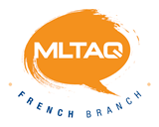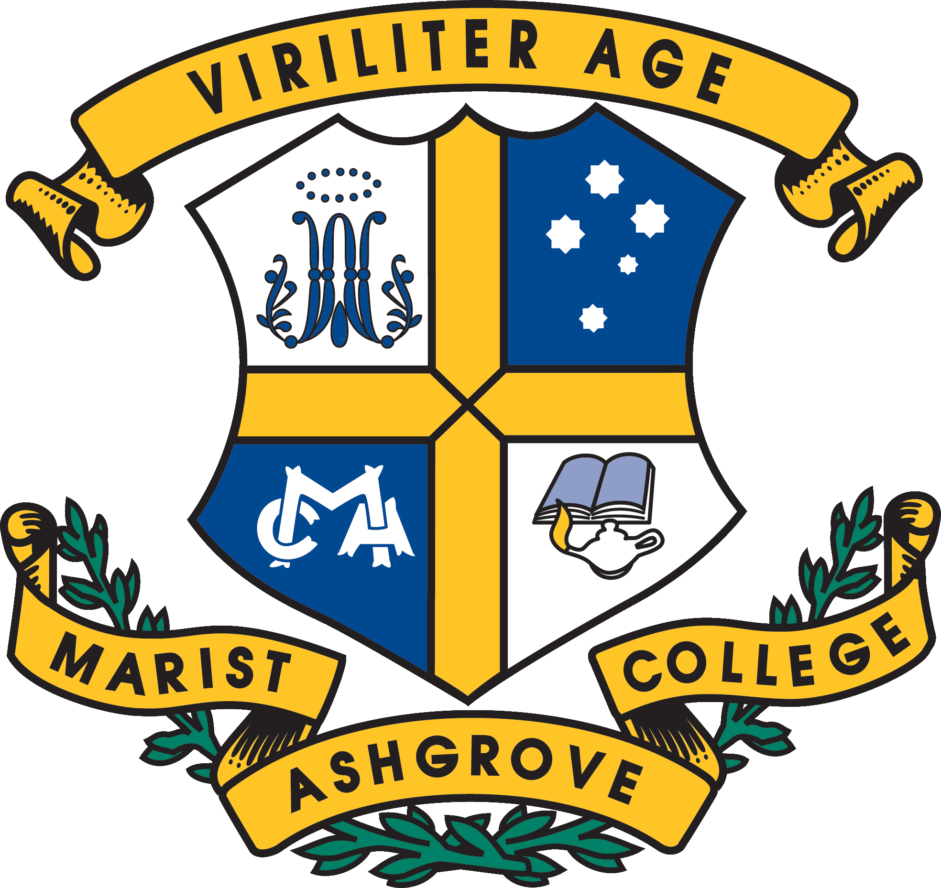
Senior French Dinner: 22nd February 2023
Booking Form
To be sent to: delvecchiol@marash.qld.edu.au by 30th November 2022
We regret that we cannot accept late applications
School:

Finance Dept email:
Attending teacher name(s) (max 2):

Number of Students (max 20 per school):

Student Names:
Place | First Name | Surname | Regular Meal / Vegetarian Option
- Prof 1
- Prof 2
*: Vegetarian option available
**NB: these are confirmed numbers incl teachers will be invoiced via a separate invoice for @ $40 pp. by the
treasurer of the MLTAQ
With thanks

