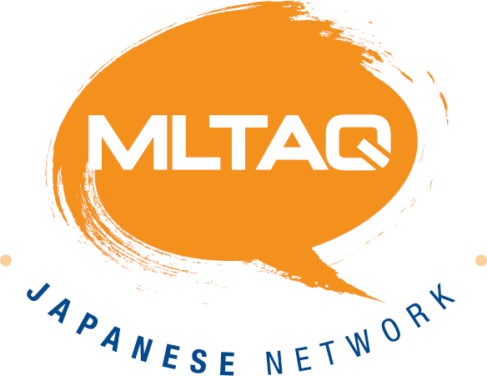

- Describe one of the following:

  - Your family

  - Your pets

  - Something you really like
2022 MLTAQ BRISBANE LANGUAGES SPEAKING COMPETITION
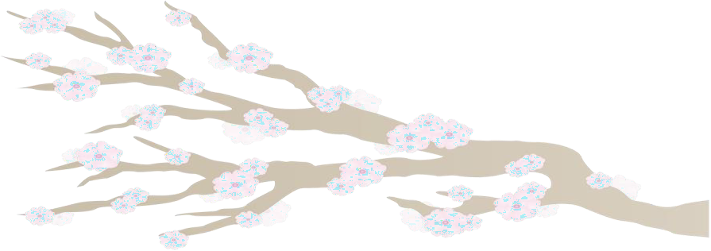
JAPANESE DIVISION 2 YEAR 4 OPEN DIVISION SPEECH

  - Your school (favourite subject, etc.)

- Judges will ask 3 follow-up questions in Japanese based on the content of your speech.

Note: Time limit is 1 minute and 30 seconds.

- No palm cards or notes are allowed
- No gestures are to be used other than greeting and farewell
- Judges will consider the content, range of language, accuracy, delivery and responses to questions.

- Describe one of the following:
2022 MLTAQ BRISBANE
LANGUAGES SPEAKING COMPETITION
JAPANESE DIVISION 5 YEAR 5/6 OPEN DIVISION SPEECH

  - Your family

  - Your pets

  - Something you really like

  - Your school (favourite subject, etc.)

- Judges will ask 3 follow-up questions in Japanese based on the content of your speech.

Note: Time limit is 1 minute and 30 seconds.

- No palm cards or notes are allowed.
- No gestures are to be used other than greeting and farewell.
- Judges will consider the content, range of language, accuracy, delivery and responses to questions.

