Minutes: Thursday, 15 July 2021 4:00 for 4:30pm
Venue: Griffith University Gold Coast Campus G27_1.11 (Business 2 Building)

Attendance:
Leigh Kirwan (Griffith University), Cathy Galligan (Benowa SS), Loretta Kishihara (Upper Coomera State College), Aileen Seidman (Saint Stephen’s College), Simone Sebban (St Hilda’s School), Jackie Mikami (Foxwell SSC), Matthew Spiller (Springwood SS), Mikki Ellis (Elanora SHS), Anna Belousova (Russian school), Fuxin Li (Debbie) (Varsity College), Kumiko Katayama (Griffith University), Tara Bible (St Andrew’s Lutheran College, Jessie Yi (Pimpama State Secondary College), Joanne Cheng (Queensland Academy for Health Sciences), Noriko Chantrill (Bellevue Park and Pimpama SS), Danielle Swainson (Somerset College), Lindsay Rawnsley (Brisbane School of Distant Education), Mariko Saito (Griffith University), Mary Spinella (All Saints Anglican School), Peter Niberg (Beenleigh SHS), Joanne Fullerton (Canungra SS).

Apologies: Giovanni Picarello, Yumi Tatton, Susie Fenton, Sandra Williamson, Yoko MacDonald, Jochen Schaich

Minutes of previous meeting and Business Arising:
Leigh moved that the agenda and the Minutes from the previous minutes be approved, Jackie seconded this and the minutes were carried.

- Correspondence in and out: N/A
- President’s Report:
- Japan and Friend’s Day is postponed to 25th, September, 2021
- EP MLTAQ Online speech competition is going ahead, Suzanne MacCallum, Experienced Senior Teacher, Rockhampton State High School is convening it. The Competition is open for submission from 28th July to 17th September. EP will be running a webinar on Wednesday 18th August at 7pm for teachers new to EP that would like some help navigating the platform which will be recorded and available. Everyone is welcome to participate (including the students who will participate in live Speech Contests). No costs are involved. Please find the Contest Rules and Judging critea attached to this meeting’s email. Details can be found on the MLTAQ website as well.

- Webmaster’s Report: Thanks to Giovanni’s effort and time the website information is current and up to date.
- General Business
Cathy Galligan reminded us about the Writing and Multimedia competition judging arrangements – the participation fee is $3 and the school should provide one judge per school. Judging will take place at Benowa SHS in Term 4 week 3, exact date TBC. A nice breakfast will be provided. The details of the competition are on the website https://www.mltaq.asn.au/goldcoast/gold-coast-print-and-multimedia. It’s important to observe a child’s privacy and put all the personal details at the back of the poster.
Aileen Seidman has also suggested creating a Digital Book with the best works.
- There was no PD due to the discussion of the Speech Contest’s details
- Speech Contest:
- Leigh has given us some update on the rooms, parking, COVID safe rules, etc. He has also mentioned that this is the 40th contest in the history of the Speech Contest. The Contest will take place on Campus, 3 carparks will be available for free. Please refer to COVID safe plan on the website of Griffith Uni. The Convenors are to be reponsible for checking in visitors and contestants. Leigh has provided Convenors with a QR code generated for each marshalling room. There are also instructions how to check-in people without a smartphone. It is very important to check in everyone. If you need to check the registration, please go to the check in app and see the History. Sanitisers and wipes will be available in each area. If you need First Aid please address the Security. An extra security guard and a cleaner on the day will be provided. If you need to print the map, it’s on the University website https://www.griffith.edu.au/campus-maps/gold-coast-map
The marshalling room plan was confirmed, please see attached to the Minutes. Rooms will be open from 7am. In case the rooms are locked please call Leigh or security. Rooms should be left the way they were found. Information desk will be at the Junction Café for people who get lost. Numbers of lunches are to be confirmed by Monday as MLTAQ is providing lunches for volunteers and judges. Medals were given to Convenors based on 2018 numbers, please follow the rules to allocate them. Please note that we will need to purchase more medals next year. If you end up will spare medals at the end – give them back at the next meeting. Amended certificates were sent out to all the Convenors. Please make sure you received them. Results should be send to Aileen to be published on the website later. Medals should be collected by teachers at the end of the Contest. If any are left - then at the next MLTAQ meeting . The certificates should be forwarded to schools. Tea and coffee can be provided in marshalling rooms for judges.

Photo from the dinner at Muso Japanese Restaurant

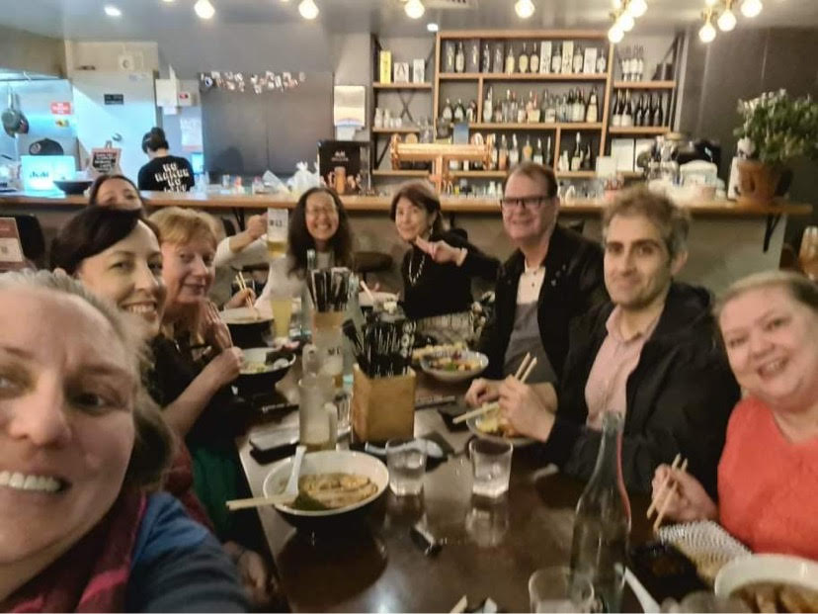

Future meetings:
Thur 05 August GC MLTAQ G27_1.11
Thur 02 September GC MLTAQ G27_1.11
Thur 07 October GC MLTAQ G27_1.11
Thur 04 November GC MLTAQ G27_1.11
Fri 03 December Christmas Party To be advised

