The Modern Language Teachers’ Association of Queensland Inc.
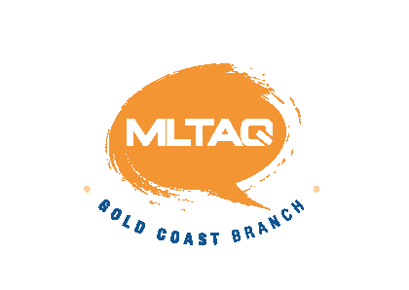 Gold Coast Branch Thursday 7 August 2014
Venue: G06_3.60 (Business 3 Building) Commenced: 4.00 concluded
Attendance:
Gabrielle Bert (Benowa SHS) , Brendan Boyle (Helensvale SHS), Cathryn Bruton (Benowa SHS), Anthony Chapman (Redland Bay SS), Sofia Chu (King’s Christian College), Chris Dunn (St Hilda’s), Sharyn Fujie (William Duncan SS), Jo Fullerton (Canungra SS), Gareth Jones (Robina SHS), Patricia Petraello (Gaven SS), Linda Ramirez (Benowa SHS), Flor Rirena (Robina SHS), Tracey Somerville (Southport SHS), Karen Preece, Seikon Nakajima (Coombah SHS), Susie Fenton (Tamborine Mountain SHS).
Welcome
Start: 4.00

Apologies
Leigh Kirwan (Griffith Uni), Rachel Lorney (Coomera SS), Kim Hepworth (Clover Hill SS).Linda Ramirez, Kath Clarke, Lisa Moller, Eve Blackwell, Ros Fischer

Vice President’s Report

- Successful North Queensland Speech Contest Completed Sat 2nd August – winners will be forwarded to Gareth and the recipients will receive the funds
- Governor of Saitama visited Robina High – he is here for the 30 year anniversary of QLD – SAITAMA relationship.
- The 2014 Biennial MLTAQ Conference will be held on Thursday 2 & Friday 3rd October at QUT – Kelvin Grove Campus – see MLTAQ website for registration details.

Webmaster’s Report
- All content is live – speech times will be up over the weekend (Tuesday at the latest)

Treasurer’s Report

- Schools appear to be paying promptly
- The bank balance is $19 145.85 (still have expenses for speech contest)
- APU, Language Perfect, JCCIB donations have been received
- Sakuragakuen and JETAA – have been invoiced for the donations but not received at the moment

General Business
- Writing comp – cover sheet – Jo to send to Anthony for an update as does not match categories
- Speech contest – state contest issue - Sunshine Coast wants to enter the state comp – they need to enter the gold coast comp first and then if they are good enough they will then go through to the State comp. The only people that get direct entry to the state comp is winners of a regional competition
- Karen is doing program
- Chris is taking the photographs of the winners at the ceremony
- Singer is a Spanish Student from Indoroopilly State Comp.
- Sunday 17 August
- Entertainment schedule – Brendan gave a run through of the schedule - He is still looking for more presenters – he will give the schedule to Anthony to put on website
- Each section will receive a 20 dollar voucher to give out for a lucky participant on the day and post the winner along with the winners in each section
- The results will be posted at marshalling and announced at entertainment.
- PD at Benowa SHS on Tuesday afternoon for language perfect

Professional Development Start: 5.00

- Queensland Academy Creative Industries – Karen Preece – Differentiation in the Flipped Classroom

Thur 5 June GC MLTAQ G06_3.60
Thur 19 June GC Speech Contest Sub-Committee G06_3.60
Thur 17 July GC MLTAQ G06_3.60
Thur 31 July GC Speech Contest Sub-Committee G06_3.60
Thur 7 August GC MLTAQ G06_3.60
Sun 17 August Speech Contest Various
Thur 4 September GC MLTAQ G06_3.60
Thu 9 October GC MLTAQ G06_3.60
Thu 6 November GC MLTAQ G06_3.60
Wed 3 December Christmas Party

