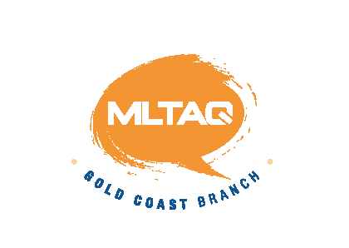The Modern Language Teachers’ Association of Queensland Inc.
Gold Coast Branch Thursday 1st August 2013
Venue: G06_3.60 Commenced 4:13 Concluded 5:40
Attendance :Gabrielle Bert(Benowa SHS), Eve Blackwell, Brendan Boyle (Helensvale SHS),Cathryn Bruton (Benowa SHS), Anthony Chapman (Redland Bay SS), Chris Dunn (St Hilda’s), Ros Fischer, Jo Fullerton (Canungra SS),Kayoko Govindasamy (Elanora SHS),Kim Hepworth (Clover Hill SS, Palm Beach SS), Gareth Jones (Robina SHS ), Loretta Kishihara, Leigh Kirwan (Griffith Uni), Takanobu Kodashima, Rachel Lornie, (Tomoko Nakanishi (Arundel SS), Mariko Saito (Griffith Uni, St Brigid’s PS), Fumiya Sato, Judy Shelley (Colours of the World), Michele Soulard (QAHS),
Welcome By Leigh
Cathryn introduced Mr Sato and Mr Kodashima who were visiting Benowa with a study group from Japan.
Apologies:
Jackie Mikami, Susie Fenton, Victor Laredo-Rodriquez, Lisa Moller, Linda Raming.
President’s Report
- JNTO Seminar
An interesting evening was provided for teachers. Kerry Forest did a presentation on the sites in Japan she takes her students too. There were presenters from different prefectures. A thankyou book, chopsticks and posters as well as a lovely mug from Saizen Tours were gifts attendees received. After the meeting delicious finger food was provided.

- Possible Qld Japanese Conference in conjunction with Japanese Consulate.
The acting consulate is very keen for collaboration between MLTAQ and the Japanese Consulate

- Yosakoi Dancers will do a short performance and tell members what services they could offer schools teaching Japanese at our next meeting on 5 September in G39_3.38

Web Masters Report
Everything for the contest including a written speech for the indigenous language is available.

Treasurer’s Report
Registrations have been flooding in. As payment has come in the registration forms have been sent straight on to the convenors.
Currently $11 316.94 in the account

Speech Contest
Report from Sub Committee meeting.
- Announcement of all winners to be posted outside the language marshalling rooms.
- The judges will receive a $7 lunch voucher
- There will be no student ambassadors this led to a discussion and a decision to look into employing 2 students on the day to act as ambassadors and guides...
- Discussion regarding the provision for lunch for teachers. Teachers helping our on the day will be provided with a lunch voucher.

- Program: Michelle Endicott will be our guest speaker

- Wine and Cheese: Will be provided by Ros and Eve

- Sponsors:
APU would like a booth to promote their product and services at the speech competition. Perhaps the best place for this booth would be near the Secondary Marshalling area.

Tourism Confucius Institute will also provide activities for children to do. Consequently they will also need a table near the café.

Criteria for regional entrants into our speech competition, needs to be up one the web to provide information for next year’s speech competition.

Ros will represent our Branch at the Sunshine Coast MLTAQ Speech competition on August 25th.

Victor has requested that a new division be created for Yr 6 Spanish.

The award ceremony will include the Senior Chinese speech.

General Business
Loretta gave a talk on MLTAQ Peninsula Branch. The Branch has regular monthly meetings. Once a year they have an MLTAQ PD. This year it was on Saturday 27th July. Sherryl Saunders was a guest speaker. Approximately 18 members attended.
Chris Dunn: A similar Japanese symposium to the one held in Melbourne last year is being planned for July 2014 in Sydney.

Next Meeting
- 5 September in G39_3.38

