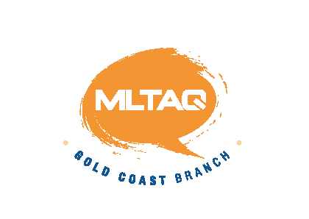The Modern Language Teachers’ Association of Queensland Inc.
Gold Coast Branch Thursday 11th July 2013
Venue: G06_3.60 Commenced 4:07 Concluded 5:26
Attendance: Eve Blackwell, Brendan Boyle (Helensvale SHS),Cathryn Bruton (Benowa SHS), Anthony Chapman (Redland Bay SS), Chris Dunn (St Hilda’s), Susie Fenton ( Mt Tamborine SHS), Ros Fischer, Sharon Fujie (William Duncan SS), Jo Fullerton (Canungra SS), Kayoko Govindasamy (Elanora SHS), Kim Hepworth (Clover Hill SS, Palm Beach SS), Gareth Jones (Robina SHS ), Lisa Moller (Benowa SHS), Tomoko Nakanishi (Arundel SS), Linda Raming (Benowa SHS), Mariko Saito (Griffith Uni, St Brigid’s PS).
Welcome By Gareth Jones. Self introductions.
Apologies:
Leigh Kirwan, Gabrielle Bert, Jackie Mikami.
Vice President’s Report
- APU University (Ritsumeikan University) has agreed to sponsor the 2013 Speech Competition for $2 000

- We will request 300 information packs about programs run APU University’s programs to be distributed to senior students at our speech competition. Information packs will also be given to teachers to distribute to of senior students of Japanese.

- Ros Fischer and Cathryn Bruton have put together an application to The Department of Multi-Cultural Affairs for a Valuing Diversity Grant to the value of $9 000 over 3 years.

- Japan Consul General QLD Junzo Fujita is returning to Japan and will not be
able to attend the Speech Contest.

Web Masters Report
- All speeches have been put onto the web.
- Anthony was concerned that the Chinese speech was not coming up onto the website. If you are having problems please let Anthony know.
- A sound bite of the Indigenous language we are using this year will be uploaded. (Hopefully within the week).

Treasurer’s Report
- The current balance is $10 963. We have yet to receive donations that have been promised for this year’s speech competition. So for now, a very healthy balance.
- Could teachers please included the registration form with payment for the Speech Competition
Speech Contest
Again could teachers please included the registration form with payment
- JETAA has pledged $100 to our Speech Competition
- Indigenous Speech
Gareth/Ros will be the convenor of the Indigenous Speech. If you are
entering students into the Indigenous Speech Competition please
email your registration to Gareth at gjone59@eq.edu.au
Medals for this competition will be 1^{st,} 2nd and 3rd.

- Food Stalls are no longer going to be operating.
- Koala Café will be providing a Multi-Cultural feast. Vouchers will be given out to the judges to enable them to go and buy lunch.
General Business
Japan School Excursion Seminar
The Japan National Tourism Organisation invites teachers to a seminar to learn more about Japan. Tour operators will be available on the night
Venue Watermark Hotel & Spa Gold Coast Atlantis 3032 Surfers Paradise Blvd
Date Tuesday 23rd July 2013
RSVP to japanseminar2013@gmail.com with your full name, school name, job title and email address by Monday 15th July
Lisa Moller has been awarded $3 000 from the Italian Language Centre to resource the Italian program at Benowa State High School. Benowa SHS is very grateful to the Italian Language Centre for their donation and support.
Next Meeting
Thursday 1st August Venue G06_3.60

