The Modern Language Teachers’ Association of Queensland Inc.
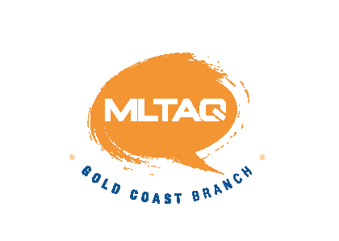 Gold Coast Branch Thursday 4th February 2016
Venue: G06_3.60 (Griffith Business School)

Commenced: 4.05 Concluded 5.50
Attendance:

Eve Blackwell, Cathryn Cooper (Benowa SHS), Anthony Fara (Redland Bay), Chris Dunn (St Hilda’s), Kim Hepworth (Clover Hill SS), Lisa Moller (Benowa SHS), Anna Siu (Varsity College), Ai Nishijima (Miami SHS), Kath Kirkpatrick (Rivermount College), Leigh Kirwan (Griffith University), Jodie Ishizaka (Coomera SS), Jackie Mikami (Park Lake SS), Remi Fukushima (Park Lake SS), Gareth Jones (Robina SHS), Tracey Somerville (Upper Coomera SC), Trina Nakahashi (Guardian Angels Primary School), Sofia Chu (King’s Christian College)

Welcome
Welcome by Leigh Kirwan.

Apologies
Linda Ramirez

President’s Report
- We have speech contest convenors. Both Rachel Vickers and Jerome Richalot have volunteered. The meeting decided it would work best if they were joint convenors this year.
- Ready? Set? Plan! 12th March Brisbane workshop fully subscribed – may be a following one in Brisbane or Gold Coast
- Membership now due. See http://www.mltaq.asn.au/membership
- ALL LANGUAGES Teacher PD Event Thu 10/Fri 11 March $160 pp Register at HTTP://events.isq.qld.edu.au/id/693
- Ipswich Harmony Day Festival, 3 – 8pm Sat 12th March, Robelle Domain Park, Education City Drive, Springfield Central

Webmaster’s Report
- Anthony provided an overview

Treasurer’s Report
- The current balance is $14,804.21
- Applications are progressing to enable us to take online payments

General Business

- The Writing Competition meeting at Nerang was well attended. Entries close on Friday 9 September and there will be a $2 entry charge. Judging will take place at St Hildas on 29th September.
- Cathryn announced that Benowa has received funding for research on “Raising community awareness of the benefits/value of language learning will affect student retention in language programs.”

Dinner this month was at Nozomi.

Future meetings:

Thur 14 April GC MLTAQ G06_3.60
Thur 05 May GC MLTAQ G06_3.60
Thur 19 May GC Speech Contest Sub-Committee G06_3.60
Thur 02 June GC MLTAQ G06_3.60
Thur 16 June GC Speech Contest Sub-Committee G06_3.60
Thur 14 July GC MLTAQ G06_3.60
Thur 04 August GC MLTAQ G06_3.60
Sun 14 August Speech Contest Various
Thur 01September GC MLTAQ G06_3.60
Thu 06 October GC MLTAQ G06_3.60
Thu 03 November GC MLTAQ G06_3.60
Wed 07 December Christmas Party TBA

